**POTENTIAL FISHING AREA RECOGNITION AND GUIDANCE SYSTEM**

Amrith Venkat K, III Year EIE, Sri Ramakrishna Engineering College

Mukesh Kumar, III Year EIE, Sri Ramakrishna Engineering College

Jeevaraam K, II Year EIE, Sri Ramakrishna Engineering College

Rakul Kannan K, II Year EIE, Sri Ramakrishna Engineering College

***Under Guidance of***

Dr.K.Srinivasan, Head of Department, Department of Electronics and Instrumentation Engineering,

Sri Ramakrishna Engineering College

In Today’s Scenario, the location of potential availability of fish remains as a system which does not reach the fishermen in an effective manner. The location is present as data in the website or server and on the Coasts as a display on LCD Screen. This project aims to acquire this data for the use of even small-scale fishermen and guide them to reach the potential fishing spots near their location. This system makes it possible for the fishermen to reach these spots with ease. This system will be in continuous contact with the fishermen and will be with them all the time.

This Project consists of two Systems, the Shore System and the Mobile System. The Shore System is basically a self-service system. It is kept connected to the internet and used to acquire and update the potential fishing areas. These potential fishing areas are mapped by Remote Sensing Technologies and made available to the Public by the Government itself under the name of INCOIS (Indian National Centre for Ocean Information Service). The Potential Fishing Zones are divided into 14 coastal regions throughout the country. This data is hosted in a Public domain by Government. This data is downloaded by the Shore System and the data is converted to a specific format readable by the Mobile System. This data is then transferred to the SD Card of the user.

The Mobile System consists of GPS Receiver, Central Controller, LCD Display and SD Card Reader. The Central Controller consists of Arduino unit and Four Input buttons. The Mobile System first checks for the stored Location Data in the SD Card. If data is found, the location will be displayed to the user from which the user can select his preferred destination region. Then, the system starts to receive the present location data from the attached GPS Module. The Controller compares the present location with the user defined location and indicates its absolute bearing and distance to location. If the location is reached, a signal indicating their arrival at the location is displayed. Caution is taken to see that international water boundaries are not crossed by referencing the co-ordinates present on the SD card and the Internationally agreed boundaries.

The Potential Fishing Zone data is refreshed by the INCOIS frequently. While the user registers himself for the first time in the Shore System, his contact number is also received and stored. Whenever the INCOIS data is refreshed and the Shore System completes updating the same, an intimation will be sent to the registered contact numbers so that the Potential Fishing Zones are not out-dated. The International Border Co-ordinates are stored in such a way that these data cannot be tampered with. In addition to these precautions, the Shore System feeds a special message to the SD Card regarding the region of the fishermen so that the fishermen of one region do not go to other regions and exploit the opportunities of native fishermen of that region.

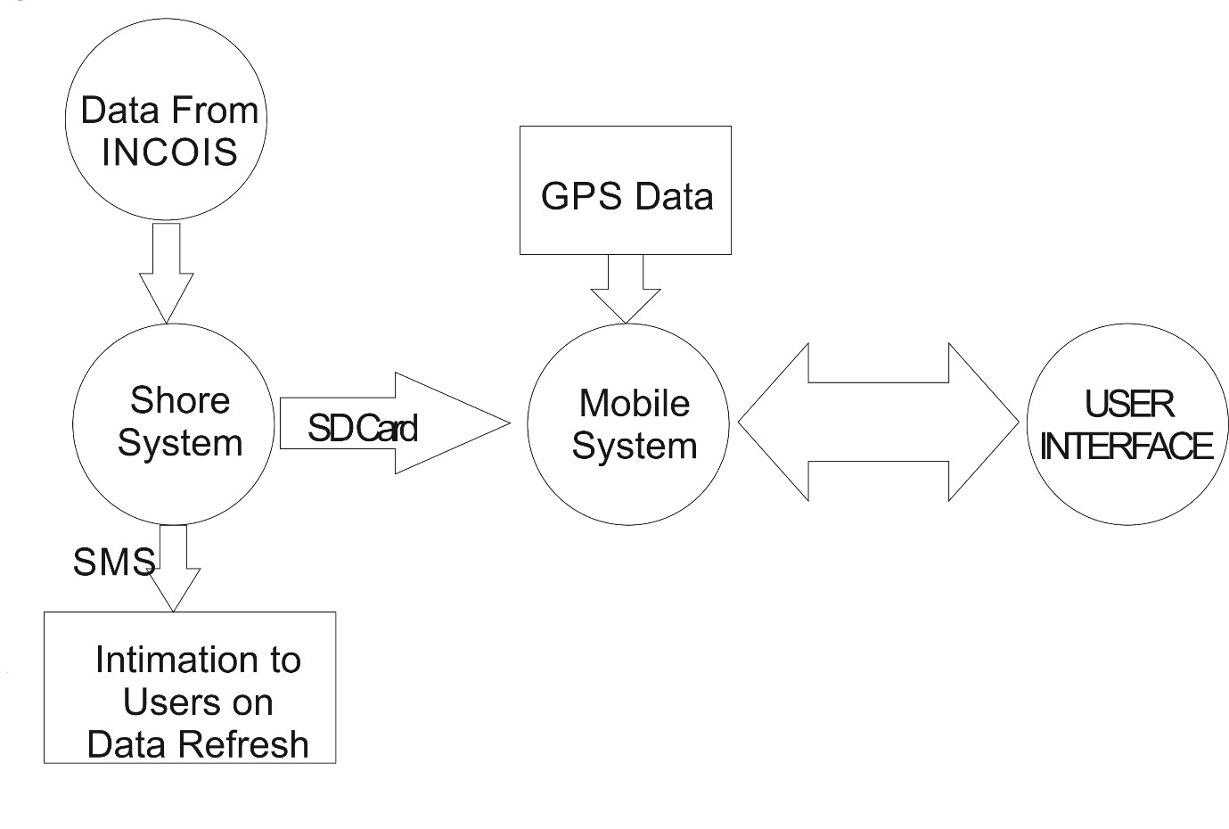

**Fig 1 Complete System Overview**

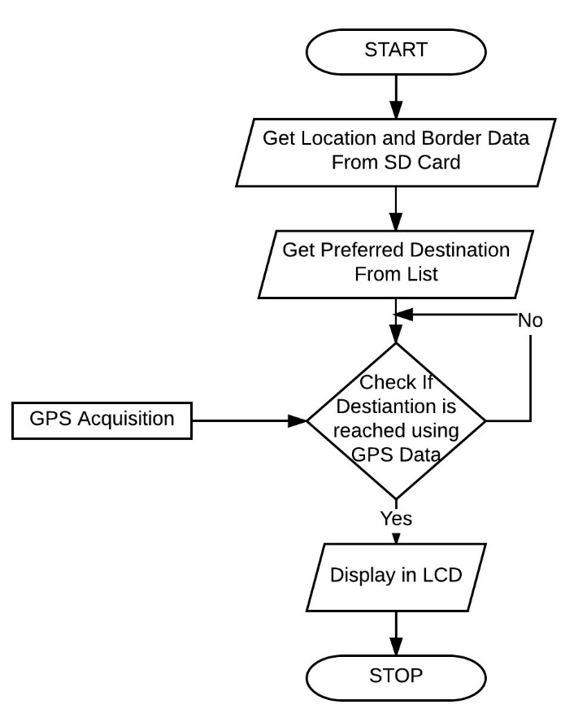

**Fig 2 Flowchart For Mobile System Operation**

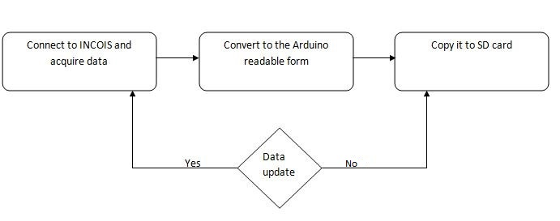

**Fig 3 Shore System Overview**

The Mobile System also logs the present GPS Data to the attached SD Card every five minutes. At present, there is another ongoing conflict that Sri Lankan Navy arrests fishermen due to potential threat of terrorists. In such case this log can be used as a proof that they have no wrong intentions. This log can also be used by NGOs and other Government agencies to monitor and guide the efficient route to the destination and enable such organizations to provide knowledge about route planning efficiency. In Extreme Cases, if the fishermen are taken hostages by Pirates or any other anti-socialists, this GPS Log could be used as a proof for detecting and identifying the base of operations of such anti-socialistic groups.

This Project not only aims to make the Potential Fishing Zone more realistically available to fishermen but also to make the data available to lower-class fishermen too. The cost would be very minimal when compared to conventional one which makes this system a more-efficient one. The Tertiary merits of this system include that the ratio between energy used and income from fishing could increase as this system guides the fishermen directly to a more reliable area than the fishermen using their long-acquired instinctual knowledge.